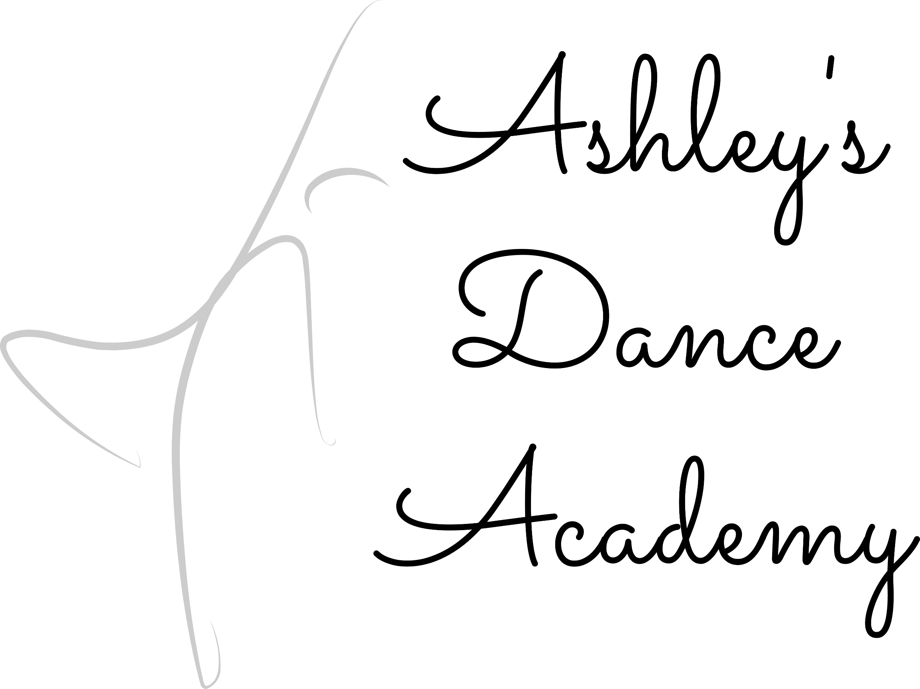
4 Washington Ave. E Albia, Iowa 52531
641.799.4569 ashleysdanceacademy@yahoo.com
www.ashleysdanceacademy.com

Combo Options: A Combo can be created for 2 to 3 classes

IRISH STEP DANCING: Dancer must take soft shoe to take hard shoe.
(Soft Shoe can be taken alone).

Pointe’: Pointe may only be taken if you have taken it last year. If you wish to work towards pointe, you may sign up for classical ballet.
Registration Prices: Registration is due when signing dancer(s) up for classes
1 Student: $50.00 - 2 Students: $75.00 - 3 Students: $85.00
4 Students & More: $95.00
________________
3 Benton Ave. E
Albia, Iowa 52531
641.891.2578
shannondance@hotmail.com
www.shannonsschoolofdance.net

Age 4: Combo Options: BALLET – TAP - JAZZ
Ages 5 – 8: Combo Options: BALLET – TAP – JAZZ
HIP HOP POMS IRISH STEP DANCING: SOFT SHOE-HARD SHOE CLASSICAL BALLET
Ages 9 – 12: Combo Options: LYRICAL – TAP – JAZZ
IRISH STEP DANCING: SOFT SHOE – HARD SHOE
HIP HOP POMS CLASSICAL BALLET
JUNIOR HIGH – HIGH SCHOOL:
Combo Options: CONTEMPORARY – TAP – JAZZ
IRISH STEP DANCING: SOFT SHOE – HARD SHOE
HIP HOP POINTE’ POMS CLASSICAL BALLET
ADULT: Combo Options: TAP – HIP HOP - CONTEMPORARY

-----------------------------------------------------------------------------------------------------------------
Name of Student: ____________________________
Age: ___ Date of Birth: ____________ Grade_____
Medical Issues that the Studio Needs to Be Aware of:
___________________________________________
Scheduling Conflicts (Please be very specific): _________________________________________
__________________________________________
Dance Styles Chosen:

Name of Student: ____________________________
Age: ___ Date of Birth: ____________ Grade_____
Medical Issues that the Studio Needs to Be Aware of:
___________________________________________
Scheduling Conflicts (Please be very specific): ___________________________________________
__________________________________________
Dance Styles Chosen:

PARENTS/GUARDIANS______________________________________________________________________
MAILING ADDRESS_________________________________________________________________________
PHONE NUMBER (1 )_____________________________ CONTACT PERSON__________________________
PHONE NUMBER (2 )_____________________________CONTACT PERSON___________________________
EMAIL ADDRESS___________________________________________________________________________
This form must be signed and dated for you or your dancer to be able to participate in dance class.
Signature: __________________________________________ Date:___________________________________________

